**IDENTIFICATION OF GLAUCOMA USING DEEP LEARNING**

**R.PRAVEEN 1*, M RAYMON ADITYA 2*,R.S.RISHI GOWTHAM 3\***

**DR.L.BHAGYALAKSHMI 4\***

**[1,2,3] UG Scholar , [4] Professor, Dept of ECE, Rajalakshmi Engineering College**

***Abstract -******Glaucoma is a related eye disorders that cause damage to the optic nerve which carries information from the eye to the brain. Glaucoma initially causes peripheral vision loss and eventually can lead to permanent blindness. It is estimated that there are more than 60*** *million* ***cases of glaucoma worldwide and it will increase to 80 million by 2020. More than 90 percent of cases of glaucoma remain undiagnosed in the community. Because glaucoma is often painless, people may become careless about strict use of eye drops that can control eye pressure and help to prevent permanent eye damage. Ophthalmologists may use perimetry, tonometry, and ophthalmoscopy to diagnose a glaucomatous eye.Computer-aided autonomous detection of glaucoma is possible using deep learning. This paper presents a generalized deep learning model for glaucoma detection using fundus images from ACRIMA database . Unlike traditional methods where the optic disc features are handcrafted, the features are extracted automatically from the raw images by Convolutional neural network (CNN) .In our CNN model AlexNet architecture is being utilised for auto feature detection***

***Keywords – CNN, AlexNet ,Glaucoma,ACRIMA dataset,OCT(optical coherence tomography).***

**I.INTRODUCTION**

Glaucoma is the second most common cause of blindness worldwide. WHO has estimated that 4.5 million people are blind due to glaucoma. The estimated prevalence of glaucoma is 2.65% in people above 40 years of age. Glaucoma prevalence increases with age. In India, glaucoma is the leading cause of irreversible blindness with at least 12 million people affected and nearly 1.2 million people blind from the disease. Glaucoma has been called the "silent thief of sight", because the loss of vision usually occurs slowly over a long period of time.Cataracts caused 51% of blindness in 2010, while glaucoma caused 8%. Little is known about the prevention of glaucoma, however, early diagnosis and treatment is the best way to prevent vision loss from glaucoma. Increased air pollution have put the human population at risk to glaucoma [1]. The prevalence of POAG( primary open-angle glaucoma) in rural south India among 40+ population was estimated as 1.7% in the ACES study[1]. The prevalence was comparatively higher in the urban south India-Chennai Glaucoma Study (3.5%). More importantly it was observed that more than 90% cases of glaucoma were undiagnosed and identified only at the time of survey (98.6% in the Chennai Glaucoma Study).The National Blindness survey 2001 showed that glaucoma is the third major cause of blindness in India and responsible for 5.9% of blindness[2].There has been a more than threefold increase in proportion of glaucoma blindness compared to that found in the previous National survey in 1986-1989 .It is perceived that glaucoma blindness is underestimated in these surveys as the blindness is defined on visual acuity criteria instead of visual fields which are defining criteria for glaucoma[4].

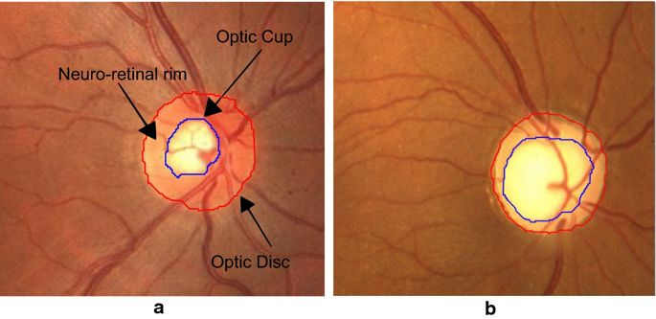

**Figure1:** Digital fundus images cropped around optic disc. a) Main structures of a healthy optic disc and  b) glaucomatous optic disc.

**II.EXISTING WORK**

Convolutional neural networks have been used by researchers before for glaucoma detection. One example is the work of Chen et al. [6]. He and his colleagues used a deep learning model that includes six learned layers as well as dropout and data augmentation methods on two private fundus datasets, ORIGA(-light) and SCES, to automatically detect glaucoma. The training and testing of images were done using one or both datasets. Alghamdi et al.[7] used two successive deep learning architectures to detect optic-disc abnormalities. Initially, a total of eight datasets, four public and four private, were used for optic-disc localization and then two of them were used separately for abnormality detection[5].

Another example of glaucoma detection using deep learning is the work of Abbas [8]. He, first, used a convolutional neural network architecture to extract the needed features and then, he used a deep-belief network to select the most discriminative features and finally, using a softmax linear classifier he detected glaucoma. He used three public and one private datasets separately to test and train the deep learning architecture. The work of Orlando et al. [9] utilized two different convolutional neural networks, OverFeat and VGG-S, as feature extractors and a few preprocessing techniques for automated glaucoma detection. Evaluation of the work was done on Drishti-GS1 dataset.The previous works were based on machine learning techniques which involved manual selection of feature from OCT images

Previous works were based on manual selection of features from OCT images but in deep learning auto feature detection is possible.Existing works are based on detection using GoogleNet

**III.PROPOSED WORK**

The proposed work is based on ACRIMA OCT and fundus dataset which contains about 396 glaucoma positive images and 309 glaucoma negative images In this project the dataset is splitted into two training sets each containing equal data(ie. images). There are about 300 images for training in each classification.AlexNet proved to be the suitable architecture for training this dataset.

|  |  |  |  |
| --- | --- | --- | --- |
| **Dataset** | **glaucoma** | **Non glaucoma** | **total** |
| **ACRIMA** | **396** | **309** | **705** |

**1.Architecture of AlexNet**

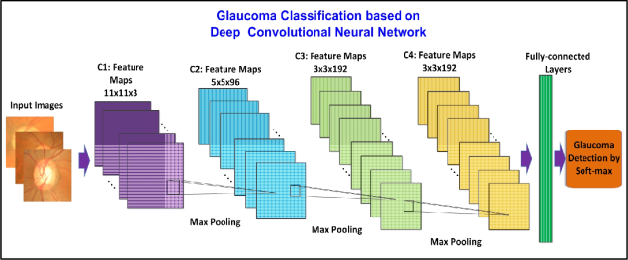

**Figure2**: deep learning generic framework proposed in our model

**a)First Layer:**  
The input for AlexNet is a 227x227x3 RGB image which passes through the first convolutional layer with 96 feature maps or filters having size 11×11 and a stride of 4. The image dimensions changes to 55x55x96. Then the AlexNet applies maximum pooling layer or sub-sampling layer with a filter size 3×3 and a stride of two. The resulting image dimensions will be reduced to 27x27x96.

**b)Second Layer:**Next, there is a second convolutional layer with 256 feature maps having size 5×5 and a stride of 1.Then there is again a maximum pooling layer with filter size 3×3 and a stride of 2. This layer is same as the second layer except it has 256 feature maps so the output will be reduced to 13x13x256.

**c)Third, Fourth and Fifth Layers:**  
The third, fourth and fifth layers are convolutional layers with filter size 3×3 and a stride of one. The first two used 384 feature maps where the third used 256 filters. The three convolutional layers are followed by a maximum pooling layer with filter size 3×3, a stride of 2 and have 256 feature maps.

**d) Sixth Layer:**  
The convolutional layer output is flatten through a fully connected layer with 9216 feature maps each of size 1×1.

**e)Seventh and Eighth Layers:**  
Next is again two fully connected layers with 4096 units.

**f)Output Layer:**Finally, there is a softmax output layer ŷ with 1000 possible values.

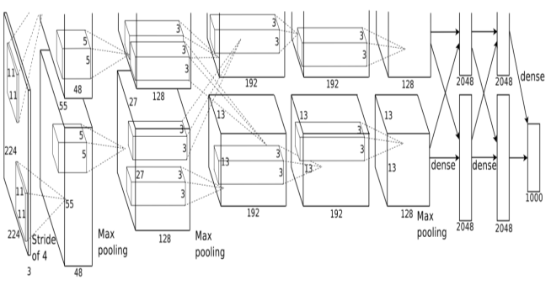

**Figure3:**Illustration of AlexNet’s architecture.

**Dataset :**

ACRIMA database is composed of 705 fundus images (396 glaucomatous and 309 normal images). Most of the fundus images from this database were taken from the left and right eye previously dilated and centred in the optic disc. Some of them were discarded because of artefacts, noise and poor contrast. They were captured using the Topcon TRC retinal camera and IMAGEnet® capture System. Images were taken with a field of view of 35°.

All images from ACRIMA database were nnotated by two glaucoma experts with 8 years of experience. No other clinical information was taken into account while providing labels for the images. This first version of ACRIMA database could only be used for classification tasks. Optic disc and optic cup segmentation are not provided.

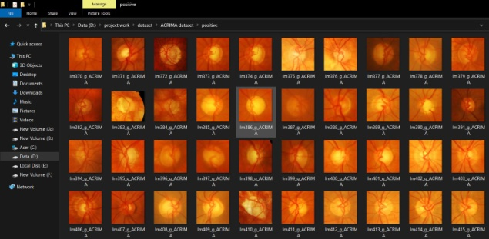

**Figure4:**ACRIMA dataset consisting of OCT fundus images , 396 glaucomatous and 309 normal images in the computer.

|  |  |
| --- | --- |
| **Layer** | **Parameters Description** |
| 'input' | 227x227x3 images with normalization |
| 'conv1' | 96 11x11x3 convolutions with stride:  [4 4] and padding: [0 0] |
| 'relu1' | ReLU |
| 'norm1' | Channel normalization |
| 'pool1' | 3x3 max-pooling with stride:[2 2] and  padding:[0 0] |
| 'conv2' | 256 5x5x48 convolutions with stride:  [1 1] and padding: [2 2] |
| 'relu2' | ReLU |
| 'norm2' | channel normalization |
| 'pool2' | 3x3 max-pooling with stride:[2 2] and  padding:[0 0] |
| 'conv3' | 384 3x3x256 convolutions with stride:  [1 1] and padding:[1 1] |
| 'relu3' | ReLU |
| 'conv4' | 384 3x3x192 convolutions with stride:  [1 1] and padding: [1 1] |
| 'relu4' | ReLU |
| 'conv5' | 256 3x3x192 convolutions with stride:  [1 1] and padding: [1 1] |
| 'relu5' | ReLU |
| 'pool5' | 3x3 max-pooling with stride: [2 2] and  padding: [0 0] |
| 'fc6' | 4096 fully connected layer |
| 'relu6' | ReLU |
| 'fc7' | 4096 fully connected layer |
| 'relu7' | ReLU |
| 'fc8' | 1000 fully connected layer |
| 'prob' | softmax |
| 'classificationLayer' | cross-entropy |

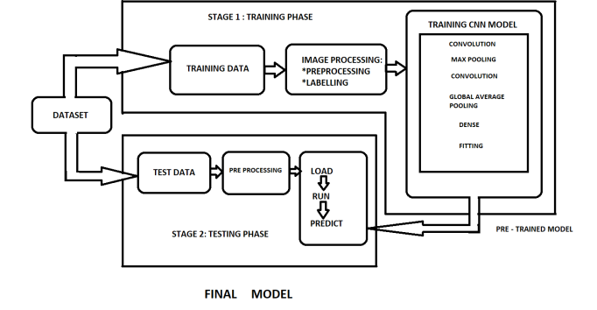

**Figure5:** Training and testing phase

a)[ReL](https://ml-cheatsheet.readthedocs.io/en/latest/activation_functions.html#id8)u

A recent invention which stands for Rectified Linear Units.The formula is deceptively simple: max(0,z)max(0,z).Despite its name and appearance, it’s not linear and provides the same benefits as Sigmoid but with better performance.

R(z)={z0z>0z<=0}

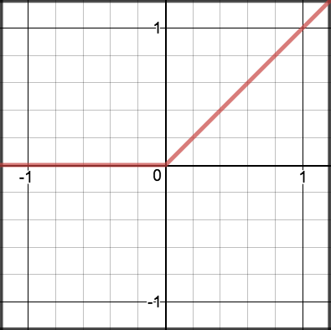

**Figure6:**ReLu function graph

b)[Softmax](https://ml-cheatsheet.readthedocs.io/en/latest/activation_functions.html" \l "id12)

Softmax function calculates the probabilities distribution of the event over ‘n’ different events. In general way of saying, this function will calculate the probabilities of each target class over all possible target classes. Later the calculated probabilities will be helpful for determining the target class for the given inputs.

c)Padding

Padding is a term relevant to [convolutional neural networks](https://deepai.org/machine-learning-glossary-and-terms/convolutional-neural-network) as it refers to the amount of pixels added to an image when it is being processed by the kernel of a CNN. For example, if the padding in a CNN is set to zero, then every pixel value that is added will be of value zero. If, however, the zero padding is set to one, there will be a one pixel border added to the image with a pixel value of zero.

MatLab software is being used for the proposed work , we install AlexNet architecture ad-ons in Matlab.The code is divided into two parts , one is for training the dataset and another is for testing the dataset.

**d)Max Pooling**

Max pooling  is a sample-based discretization process. The objective is to down-sample an input representation (image, hidden-layer output matrix, etc.), reducing its dimensionality and allowing for assumptions to be made about features contained in the sub-regions binned.

A classic CNN architecture would look like this:

Input ->Conv->ReLU-> Conv-> ReLU->Pool-> ReLU-> Conv-> ReLU->Pool->Fully connected

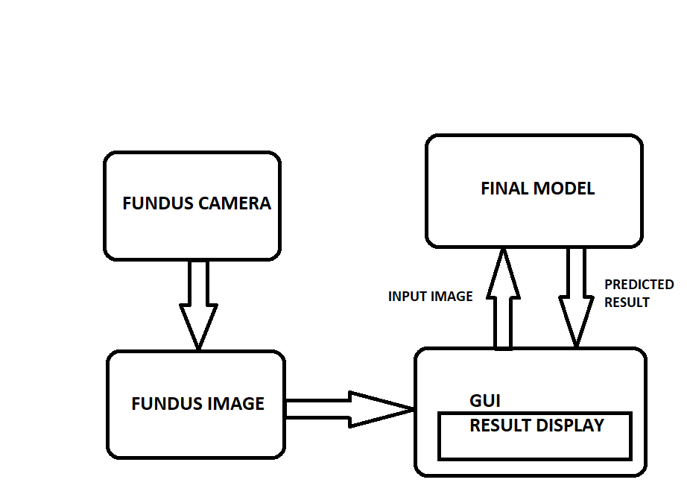

**Figure7:** Real time testing of final model by enabling GUI

**IV.RESULTS**

This model thus created by Alexnet architecture with 600 OCT images from ACRIMA dataset is fully trained and ready for testing.The testing OCT images consist of 50 mixed glaucoma/non glaucoma images from which we test our model’s accuracy.

From our model after testing its accuracy we get an accuracy percentage of 82% after testing it on 50 images.

**V.CONCLUSION**

The aim of this project is to diagnose people affected by glaucoma prematurely and help people combat glaucoma in countries like UK , Nigeria,India where risk of getting permanent blindness is high due to glaucoma unless it is found prematurely before it exacerbates

This project intends to save people like in a case of UK where a woman lost her eye sight due to Glaucoma due to delayed diagnosis and delayed appointments to meet the specialist.It aims to bring a immediate identification of glaucoma using patient’s OCT fundus image with reliable accuracy .

In this paper glaucoma identification using OCT fundus images trained from AlexNet architecture has been clearly explained

**VI.REFERENCES**

[1] (Ramkrishnan R, Nirmalan PK, Krishnada R, Thulasiraj RD, Tielsch JM, Katz J, et al. Glaucoma in a rural population of Southern India: the Aravind Comprehensive Eye Survey. Ophthalmology 2003;110:1484-90).

[2] Wood, Kathryn J.. “Glaucoma: the silent thief of sight.” The Lamp 52 8 (1995): 15 .

[3] Global Prevalence of Glaucoma and Projections of Glaucoma Burden through 2040 A Systematic Review and Meta-Analysis Yih-Chung Tham, BSc Hons1,2,∗, Xiang Li, BSc1,3,∗, Tien Y. Wong, FRCS, PhD1,2, Harry A. Quigley, MD4, Tin Aung, FRCS (Ed), PhD1,2, Ching-Yu Cheng, MD, PhD1,2,5,6,∗,'Correspondence information about the author MD, PhD Ching-Yu ChengEmail the author MD, PhD Ching-Yu Cheng Manuscript no. 2013-1669.

[4] B. Al-Bander, W. Al-Nuaimy, M. A. Al-Taee and Y. Zheng, "Automated glaucoma diagnosis using deep learning approach," 2017 14th International Multi-Conference on Systems, Signals & Devices (SSD), Marrakech, 2017, pp. 207-210.

[5] S. Serte and A. Serener, "A Generalized Deep Learning Model for Glaucoma Detection," 2019 3rd International Symposium on ultidisciplinary Studies and Innovative Technologies (ISMSIT), Ankara, Turkey, 2019, pp. 1-5

[6] X. Chen, Y. Xu, D. W. K. Wong, T. Y. Wong, and J. Liu, “Glaucoma detection based on deep convolutional neural network,” in 2015 37th

annual international conference of the IEEE engineering in medicine and biology society (EMBC). IEEE, 2015, pp. 715–718.

[7] H. S. Alghamdi, H. L. Tang, S. A. Waheeb, and T. Peto, “Automatic optic disc abnormality detection in fundus images: A deep learning

approach,” Proceedings of the Ophthalmic Medical Image Analysis Third International Workshop, OMIA, held in conjunction with MICCAI, Athens, Greece, 2016.

[8] Q. Abbas, “Glaucoma-deep: detection of glaucoma eye disease on retinal fundus images using deep learning,” Int J Adv Comput Sci Appl, vol. 8, no. 6, pp. 41–5, 2017.

[9] J. I. Orlando, E. Prokofyeva, M. del Fresno, and M. B. Blaschko, “Convolutional neural network transfer for automated glaucoma identification,” in 12th International Symposium on Medical Information Processing and Analysis, vol. 10160. International Society for Optics and Photonics, 2017, p. 101600U.

[10] The National Eye Institute (NEI): Battling global blindness, eye disease through research November / December 2012 Volume 11, Issue 6